Cassandra Assignment 02

248518 Gaurav B Raskar

Q.1.1)

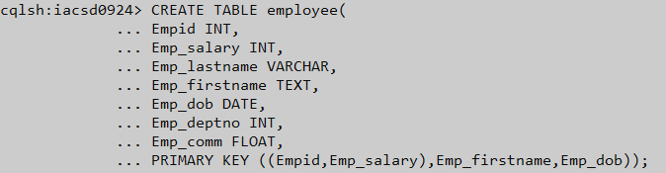

Q.1.2)